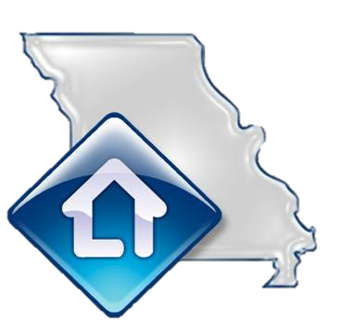
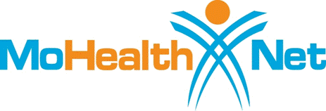


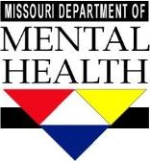
Your
Healthcare Home
HELPING YOU ACHIEVE YOUR
HEALTH AND WELLNESS GOALS
- A Nurse Care Manager is available to help you identify and achieve your healthcare and wellness goals
- Assist in helping you manage your health conditions
- Help you access a family doctor and other medical care providers
We believe that helping people lead healthier lives can greatly reduce the negative impacts of living with long-term mental illness, substance use and medical conditions. That is why MO HealthNet is collaborating with Community Mental Health Centers to serve as Healthcare Homes.
A Healthcare Home is not a place of residence. It is a place where individuals receive higher quality of care and achieve healthier outcomes. These services are covered under your current MO HealthNet plan, so there is no additional charge to you.
<AGENCY NAME>
Your Nurse Care Manager is
<INSERT NAME>
<CONTACT INFO>

<ADDRESS>
<ADDRESS>

<PHONE>
<www.WEBADDRESS.COM>

<AGENCY LOGO>
- Provide you with access to health education opportunities addressing smoking cessation, nutrition and physical activity
You can begin receiving services from your Healthcare Home today!

