SDOH Resources
Quality of Life Indicator Resources
http://ec.europa.eu/eurostat/statistics-explained/index.php?title=Quality_of_life_indicators
http://www.ipspr.sc.edu/publication/Quality%20of%20Life.pdf

The following link speaks raises the question about how do we avoid medicalizing the SDOH and the important distinction between “determinants of health” vs “determinants of well-being.” Graphic is also from this same resource.

https://nam.edu/social-determinants-of-health-101-for-health-care-five-plus-five/

2. How do we intervene without medicalizing SDoH?
There is a danger that a medical approach to these nonmedical factors will lead to more health care versus more cost-effective and community-based interventions. For example, a social worker sees a patient with schizophrenia once a week in northern Minnesota, but she says, “What this patient needs is a friend.” How do we avoid “re-creating the wheel” inside health care and increasing costs? How do we listen to communities, identify and delineate health care’s role, and collaborate appropriately with existing community resources and increase capacity? As health care professionals, we need huge doses of humility and openness to authentically address SDoH and form or join community partnerships. A recent infographic illustrates an emerging path for community collaboration—from the “aha moments” to feedback and course correction to new dialogue with the community [34].
Corollary: We often speak of the SDoH, but what are the “social determinants of well-being”? Well-being is “the sense of life satisfaction of the individual” as introduced by Evans and Stoddart in their classic paper on the determinants of health, in which they postulate that well-being is the ultimate objective of health policy [35]. Advancing “social determinants of well-being” versus health does not have the automatic association with hospitals, clinics, visits, tests, procedures, and medication that the term health has. This concept is promoted by Kottke, Stiefel, and Pronk who suggest we engage others and avoid medicalizing by focusing on “well-being in all policies” rather than health in all policies [36,37].

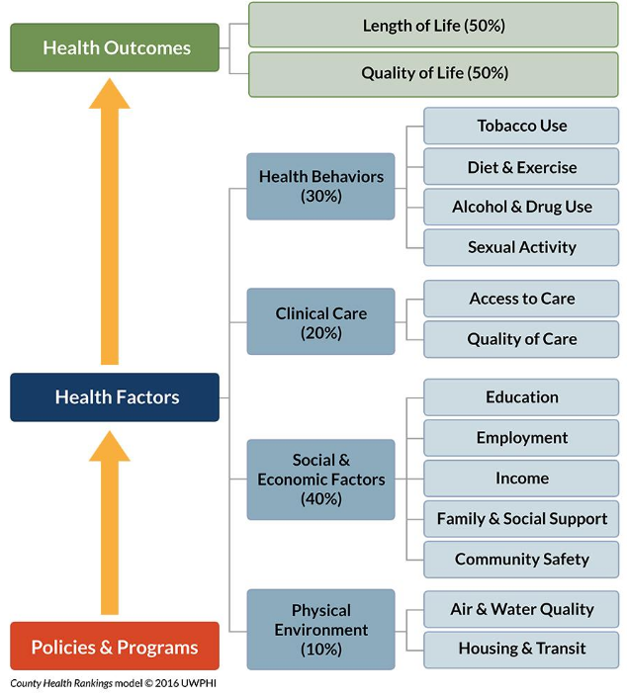
Figure 1 | County Health Rankings & Roadmaps | Source: Reprinted with permission from County Health Rankings & Roadmaps, http://www.countyhealthrankings.org/our-approach (accessed July 18, 2017).

