Missouri’s Approach to Integrated Care for
Medicaid/Medicare Dual Eligible Individuals

A. Problem Statement - In Medicare, there are approximately 3.2 million dual eligibles under age 65 with a Medicare per member per month (PMPM) cost of $639 and a Medicaid PMPM cost of $485. These high costs are due in part to the patient’s illness, and also due to the highly fragmented and often substandard care that these patients receive. Uncoordinated funding and payer systems contribute to the less than optimally effective treatment that is provided to these patients. Untreated or poorly treated medical and/or behavioral illness is a major cause of unnecessary expenditures leading to needless ER visits and avoidable hospitalizations. State Medicaid Authorities have a significant disincentive to engage in the disease management and care coordination of dual eligibles in that Medicaid would bear the cost of enhanced care management while the majority of the savings accues to Medicare. State Medicaid Authorities are unlikely to develop Health Care Homes for chronically ill dual eligibles for the same reason (Affordable Care Act § 2703).

When compared to other disabled populations, individuals with serious mental illness differ significantly in that they:

- Are more likely to suffer from multi-systemic disorders with co-occurring chronic health and behavioral health conditions;
- Are generally frequent users of a wider, more costly range of services, including psychiatric and medical hospitalizations;
- Have higher pharmacy costs due to co-occurring and chronic conditions and the need for specialty psychiatric medications;
- Are sometimes less able to manage their health and nutrition without assistance;
- Are often unemployed or under-employed, with low income and unstable housing arrangements; and,
- Frequently face challenges accessing and receiving appropriate health care due to the primary care providers’ uneasiness with trying to meet the unique needs of the SMI population, coupled with the providers’ decreased expectations of SMI patients as partners in care.

On average, SMI diagnosed individuals die at least 25 years earlier than the general population. A 2003 six-state study validated these early mortality rates and found that more than 80% of years lost was due to medical conditions, not suicide, accident or violence. Other studies have shown that persons with SMI are less likely to receive recommended preventive monitoring and evidence-based treatments for their chronic medical conditions. (“Morbidity and Mortality in People with Serious Mental Illness” National Association of State Mental Health Program Directors – Thirteenth in a Series of Technical Reports – October 2006)

B. Target Population - Missouri proposes to integrate care for dual eligible individuals with serious mental illness (“SMI”). Initially, the population will include dual eligibles with SMI who are not in institutions. The time and resources of the planning process will be used to determine how broad the definition of SMI should be in this early phase and to develop a timeline to expand the demonstration population after its initial phases to include elderly dual eligibles and a broader definition of SMI. There were 172,512 dual eligibles in Missouri at the end of 2010. Only 24,300 (14%) were in Medicare Advantage Plans. Of the remaining 148,212 persons 35,567 (24%) had an SMI diagnoses. This includes 6225 persons (18%) who were in institutions (SNF or ICF). Of the 29,342 dually eligible persons with an SMI diagnoses living in the community 41% are already receiving behavioral healthcare services through Missouri’s Community Mental Health Center Health Care Home (CMHC-HCH) initiatives described herein below and would be easy to engage in healthcare home services.

Approximately half of the Missouri (MO) Medicaid recipients who are disabled due to mental illness are dual eligibles. Moreover, approximately half of all Medicaid recipients served by Missouri CMHCs are dual eligibles. Missouri’s dual eligibles have their Medicaid benefits administered by the State, rather than being subcontracted to Managed Care Plans. Providers are paid on a fee-for-service basis. Missouri uses the Medicaid Rehabilitation Option to provide additional community rehabilitation services to persons with mental illness, substance use disorder, and developmental disability. These services are also reimbursed on a fee-for-service basis. Missouri anticipates being granted a new state plan option to provide Health Care Homes for Persons with Chronic Conditions (ACA § 2703) within the next 6-12 months. Missouri's Health Care Homes proposal includes providing health care homes through Community Mental Health Centers (CMHCs) to persons with SMI and with PMPM payments for these services. There is a great need in our state for these services as Missouri does not currently have a home and community-based waiver specifically targeting persons with mental illness.

C. Previous experience with the intervention/model proposed in the demonstration – Since 2003, the Missouri Department of Mental Health (DMH), MO HealthNet (Missouri’s State Medicaid agency), as well as the Missouri Coalition of Community Mental Health Centers, have worked together in a close partnership (DMHNet) through various projects to improve the health care of persons with SMI, including dual eligibles.

DMHNet Initiative #1 – Improving Quality of Care for Persons with Schizophrenia: In 2003, DMHNet launched an initiative to address the excessive costs related to the 19,000 Medicaid recipients who were diagnosed with Schizophrenia at that time. Of these 19,000 recipients, 2,000 had a combined cost of $100M in Medicaid claims comprised of 20% for pharmacy and 80% for psychiatric and medical services (i.e., excessive urgent care, ER and inpatient episodes). The $100M spent on these 2,000 patients represented 2.4% of all Missouri Medicaid expenditures for the State’s 1M eligible recipients in 2003.

DMHNet identified a sub-cohort of 6,061 persons who were continuously eligible for Medicaid and had monthly claims with a schizophrenia diagnosis between July 1, 2003, and June 30, 2004. (Excluded from this group were persons with an episode of care in a nursing home or with a co-occurring diagnosis of mental retardation). DMHNet conducted a more intensive sub-analysis of 1,000 persons from this group to identify the frequency of specific chronic medical conditions. This analysis found high rates of co-morbid medical disorders (cardiovascular 71%, hypertension 70%, obesity 47%, asthma 39%, and COPD 22%), fragmented care, redundant care, and gaps in care. All individuals in this subset were non-dual eligible due to lack of access to Medicare data for care coordination.

DMHNet made efforts to improve the quality of care by retraining all CMHC case managers in the area of common chronic medical illnesses. DMHNet trained case managers to collaborate with primary care providers and to provide information to primary care providers regarding services that CMHC patients received in the preceding 3-year period. Several operational problems surfaced in the process of this initiative including: (a) delays in tracking patients and providers, (b) challenges of patients not having a medical home and (c) limitations in communication with providers. As these problems arose, DMHNet worked hard to address these issues and considered this a learning opportunity to improve the quality of care in Missouri.

While this project resulted in an increase in the number of persons receiving regular ongoing care from an identified primary care physician, it did not result in actual changes in overall health care utilization/cost. Therefore, another analysis was performed to compare those individuals who had received CMHC case management service (62%) and those who had not. Health care expenditures were divided into categories of inpatient, outpatient, pharmacy, and case management. Then, the group was separated by those who received low, medium or high doses of case management. The results showed a decrease in total health care utilization for those who received high doses of case management as compared to those who only received low or medium doses of case management (20.6% and 4.7% respectively). While outpatient care and case management costs increased there was a decrease in emergency room and inpatient hospital great enough to yield a net cost reduction.(“Mental Health Community Case Management and Its Effect on Health Care Expenditures”; Psychiatric Annals 40:8, p 415-419, August 2010)

This effect was confirmed by further analysis, where total Medicaid costs were examined pre and post-enrollment in CMHC case management (CMHC-CM) services. Those studied were 636 patients newly enrolled in Missouri Medicaid’s CMHC-CM program who also had nine months of Medicaid claims in each of the two preceding years, a diagnosis of serious mental illness, a history of psychiatric hospitalization or multiple ER visits, and functional limitations as a result of their mental illness. The exact enrollment date for CMHC-CM services varied among clients, which minimized the impact of bias due to changes in the health care delivery system at specific points in time or over the study period. Average total monthly Medicaid costs were calculated for the month of CMHC-CM enrollment, the 24 months prior to enrollment, and the 24 months following enrollment for each client. Linear regression trend lines were then calculated on those pre- and post-CMHC-CM cost data. In the 24 months prior to CMHC-CM services the PMPM increased from $750 to $1750, by 12 months after entering services the PMPM, including the costs of CMHC-CM services, had fallen back to $1,250.
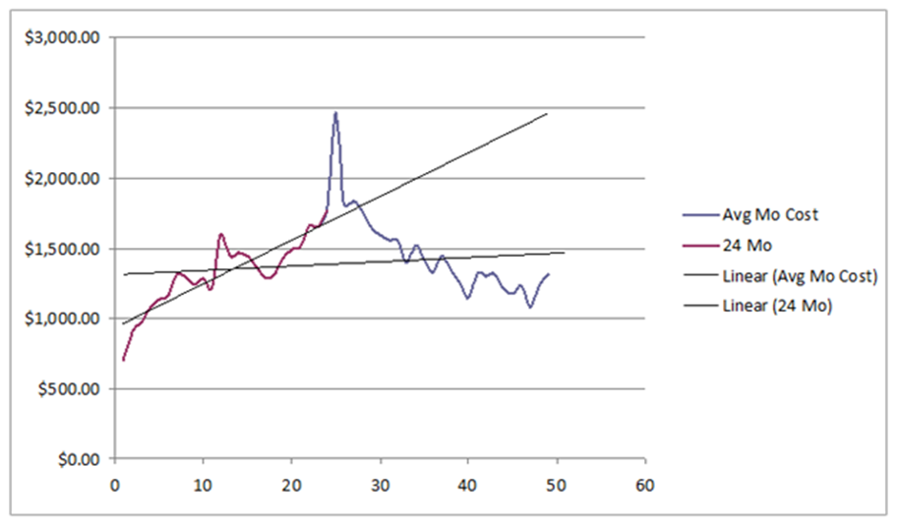
Total Health Care Utilization Per User Per Month Pre/Post CMHC Case Management

Average Medicaid expenditures
per month

Initiative #2 - Chronic Care Improvement Program: DMHNet’s next major initiative in this area was through participation in the Chronic Care Improvement Program (CCIP). In this program, APS Healthcare, Inc. identified persons likely to benefit from enhanced management interventions. The health care providers of the targeted individuals were enrolled and paid an incentive to use a health risk assessment, develop a plan of care, and use the plan of care on monthly basis. In addition, health care coaches were provided to the larger providers. CMHCs were the health care home providing the above services for 15% of all persons in a health care homes statewide under this initiative. While participating in this program, the CMHC system added primary care nurse liaisons on site at all CMHCs. They developed an independent tracking method, intervention “to do” lists, and performance outcomes with benchmark reports for 10 HEDIS indicators and medication adherence for seven different medication classes. Case managers were trained to use both the APS health risk assessment and treatment planning online tool and the MO HealthNet online EHR (CyberAccess). Independent analysis conducted by Mercer following 18 months of the implementation found that the program was almost breaking even on a statewide basis. The major reason for not showing better performance statewide was due to the full inclusion of dual eligibles which substantially diluted the cost savings related to the CCIP program.

A secondary analysis compared 6,757 clients that were in CMHCs and eligible for the APS program to those in the overall program. Missouri used the same model and time period as Mercer. The analysis compared the 86,299 persons enrolled in the overall CCIP program to the 6,757 persons in CMHC health care homes. The CMHC Health Care Home enrollees were initially more expensive ($917 vs $1556 PMPM) but had a much larger net reduction in total health care costs (-$0.91 vs $311.49 PMPM) after receiving healthcare home services. Overall CMHC health care homes were able to demonstrate a 17% cost savings off expected trend which totaled $25.2 million for the entire 6757 person cohort. The cost of the Comprehensive Psychiatric Rehabilitation Center (CPRC) services was included in the pre-post period. Off-trend savings in pharmacy (-23%) and inpatient costs (-7%) exceeded the increased utilization of outpatient care (+22%) and case management (+6%).
Initiative #3 – Disease Management 3,700 Project: DMHNet implemented the state’s third major initiative November, 2010 to provide care coordination and disease management through CMHC-based health care homes. DMHNet identified 3,700 non-dual SMI Medicaid (non-dual) recipients who were not currently receiving CMHC-HCH services. These individuals were chosen for being of the highest 25% of utilization/cost. DMHNet provided the CMHCs with the names of the 3,700 individuals for outreach and engagement in mental health services. The CMHCs will be providing these non-dual eligible SMI recipients the same healthcare home services that the State proposes for SMI dual eligibles.

Initiative #4 – Health Care Homes State Plan Amendment: As noted previously, Missouri is in the process of developing a state plan amendment (SPA) to provide Health Care Homes for Persons with Chronic Conditions pursuant to Section 2703 of the Affordable Care Act. Missouri will be using this initiative to (a) enhance the amount of primary care nurse liaison staffing available at all of the CMHCs, (b) add primary care physician consultation/support (c) enhance the State’s ability to provide transitional care between institutions and the community and (d) enable the State to provide incentive payments to the CMHCs for reducing ER visits and inpatient hospitalization, improving the quality of care, and reducing the overall cost of healthcare

